Open classes are just that - open to all ages. Those at school are welcome to enter.

Children's classes open to anyone of appropriate school age on 2nd October

All Exhibits must be entirely the work of the actual exhibitor.

Exhibitors may enter more than one article in any class to a **maximum of 3.**

Exhibits on no account will bear the exhibitors name until after the judging has taken place.

Exhibitors can enter as many classes in their age group, or older, as they wish.

**Please bring entries to the venue between 9.00am and 10.45 a.m.**

**They will not be accepted after 10.45am.**

Judging to commence at 11 a.m. Prompt.

The judges' decision is final.

Exhibits can only be removed after the prizegiving

**Name …………………………………………….**

**Tel no…………………………………………….**

**Age if at school………………………….........**

**Carluke Jampionships**

**St Athanasius Community Hall**

**Mount Stewart Street**

**Saturday 2nd October**





5



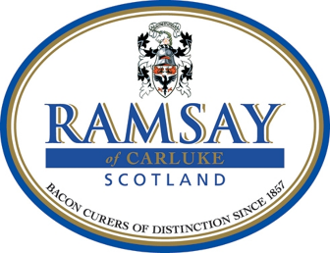

**Prize giving**

**3.00pm, Saturday 2nd October**

**Contact**

**Liz**

**Email**

**jam-carluketrust@hotmail.com**

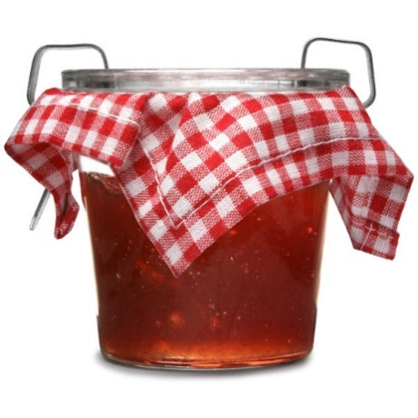

**FILL IN THIS HALF OF THIS**

**PAGE AND KEEP FOR YOUR REFERENCE**

**Please mark in entries column number of entries for that class up to a maximum of three**

|  |  |  |
| --- | --- | --- |
| entries |  |  |
|  | 1 | Raspberry jam |
|  | 2 | Strawberry jam |
|  | 3 | Marmalade |
|  | 4 | Mince meat |
|  | 5 | Chutney - any type |
|  | 6 | 3 shortbread fingers |
|  | 7 | 3 mincemeat pies |
|  | 8 | Gingerbread |
|  | 9 | Yule log |
|  | 10 | Handmade Christmas card |
|  | 11 | Christmas tea light holder – any craft |
|  | 12 | Sewn advent calendar |
|  | 13 | Christmas tree decoration – any craft |
|  | 14 | Wrapped Christmas gift |
|  | 15 | House plant in flower |
|  | 16 | Cactus |
|  | 17 | Item made in a 2021 Jam & Ham workshop |
| **Children's competition** | | |
| **Primary age** | | |
|  | 18 | 3 Christmas biscuits |
|  | 19 | Christmas tree topper |
|  | 20 | Christmas cracker |
| **Secondary age** | | |
|  | 21 | 3 Christmas cupcakes |
|  | 22 | Christmas gift for mum or dad |
|  | 23 | 3D nativity scene – any craft |
|  | 24 | A4 colour photo – Celebration! |

**FILL IN THIS HALF OF THIS**

**PAGE and email to**

[**jam-carluketrust@hotmail.com**](mailto:jam-carluketrust@hotmail.com) **or bring on 2nd October**

**Please mark in entries column number of entries for that class up to a maximum of three**

|  |  |  |
| --- | --- | --- |
| entries |  |  |
|  | 1 | Raspberry jam |
|  | 2 | Strawberry jam |
|  | 3 | Marmalade |
|  | 4 | Mince meat |
|  | 5 | Chutney - any type |
|  | 6 | 3 shortbread fingers |
|  | 7 | 3 mincemeat pies |
|  | 8 | Gingerbread |
|  | 9 | Yule log |
|  | 10 | Handmade Christmas card |
|  | 11 | Christmas tea light holder – any craft |
|  | 12 | Sewn advent calendar |
|  | 13 | Christmas tree decoration – any craft |
|  | 14 | Wrapped Christmas gift |
|  | 15 | House plant in flower |
|  | 16 | Cactus |
|  | 17 | Item made in a 2021 Jam & Ham workshop |
| **Children's competition** | | |
| **Primary age** | | |
|  | 18 | 3 Christmas biscuits |
|  | 19 | Christmas tree topper |
|  | 20 | Christmas cracker |
| **Secondary age** | | |
|  | 21 | 3 Christmas cupcakes |
|  | 22 | Christmas gift for mum or dad |
|  | 23 | 3D nativity scene – any craft |
|  | 24 | A4 colour photo – Celebration! |